**Kol simcha torah gazette**

**For parshas EIKEV 5784**

Volume 8 Issue 48 (Whole #408) 20 Menachem Av 5784/ August 24, 2024

**Printed L’illuy nishmas Nechama bas R’ Noach, a”h**

For a free subscription, please forward your request to [***keren18@juno.com***](mailto:keren18@juno.com)

***Past emails can be found on the website ShabbosStories.com under Brooklyn Torah Gazette***

**17 Facts You Should Know About**

**The Five Books of Moses**

**By**[**Yehuda Altein**](https://www.chabad.org/search/keyword_cdo/kid/17830/jewish/Altein-Yehuda.htm)

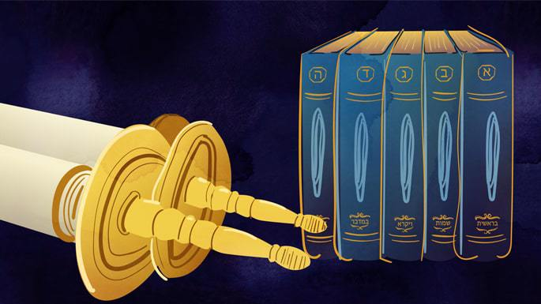

***Art by***[***Sefira Lightstone***](https://www.chabad.org/3159160)

*The Five Books of Moses, also known as the Pentateuch, are the foundational work of Judaism. Dictated by G‑d and transcribed by Moses, these books chronicle the formation of the Jewish nation and convey*[*G‑d*](https://www.chabad.org/library/article_cdo/aid/433240/jewish/God.htm)*’s instructions on how we can fulfill our life’s mission. Read on for 17 facts about the most important work ever written.*Top of Form

**Bottom of Form**

**1. They Are Handwritten on Parchment**

The Five Books of Moses form the text of the Torah scrolls kept in the ark of each synagogue. Each scroll contains 304,805 letters meticulously handwritten by a scribe using a feather quill dipped in ink, a painstaking task that takes many months to complete. The specific Hebrew script used in a [Torah](https://www.chabad.org/library/article_cdo/aid/1426382/jewish/Torah.htm) scroll is known as [*ktav Ashurit*](https://www.chabad.org/library/article_cdo/aid/3582435/jewish/What-Is-the-Authentic-Ancient-Hebrew-Alphabet.htm), with each letter following the precise specifications delineated by Jewish law.[1](javascript:doFootnote('1a6547955');)

**2. In Hebrew They’re Called “Torah” or “Chumash”**

In Hebrew, the Five Books of Moses are known as *Chamishah Chumshei Torah*, “The Five Sections of the Torah.” However, this full name is rarely used in everyday conversation. More commonly, people refer to it simply as “Torah” or “[Chumash](https://www.chabad.org/library/bible_cdo/aid/6288/jewish/Torah-The-Pentateuch.htm).”

“Torah” is most often used when it is in handwritten scroll format, and “Chumash” refers to the printed book form, used for individual study.

**3. They Were Written by Moses …**

The Pentateuch was recorded by Moses in segments over the course of the Jews’ 40-year journey from Egypt to the Promised Land. According to an alternative tradition, the content of the 5 books remained oral during that time, and was first committed to writing during Moses’ final days.[2](javascript:doFootnote('2a6547955');)

Who wrote the last 8 verses of Deuteronomy, which describe Moses’ death? The Talmud records two traditions: either it was Moses, to whom G‑d foretold what would soon take place, or it was his student Joshua.[3](javascript:doFootnote('3a6547955');)

**4. … But Authored by G‑d**

Moses may have been the transcriber, but he was not the author: every word in the Pentateuch was dictated by G‑d Himself.[4](javascript:doFootnote('4a6547955');) To quote Maimonides, claiming that Moses added a single verse of his own, or even a single word, is a denial of the Torah’s authenticity.[5](javascript:doFootnote('5a6547955');)

**5. Every Nuance Is Precise**

In light of the Torah’s Divine authorship, it comes as no surprise that every detail is perfect and exact. Jewish scholars throughout history have extrapolated laws and lessons based on the choice or sequence of the Torah’s wording, and even from the addition or omission of single letters.[6](javascript:doFootnote('6a6547955');) In fact, the Talmudic sage Rabbi Akiva is said to have deduced multitudes of laws from the little “crowns” positioned on the letters.[7](javascript:doFootnote('7a6547955');)

**6. They Are One of Three**

The Five Books of Moses are:

Bereishit (Genesis)

Shemot (Exodus)

Vayikra (Leviticus)

Bamidbar (Numbers)

Devarim ([Deuteronomy](https://www.chabad.org/library/bible_cdo/aid/8164/jewish/Devarim-Deuteronomy.htm))

Together, they form one of the three parts of the Bible (Tanakh in Hebrew). The other two parts are Prophets (8 books) and Scriptures (11 books), making a total of 24 books in the Bible.

**7. They Contain 613 Mitzvahs**

The defining feature of the first 5 books can be gleaned from their name, “Torah,” which means instruction. The 613 [mitzvahs](https://www.chabad.org/library/article_cdo/aid/1438516/jewish/Mitzvah.htm), G‑d’s master plan on how we should live our lives and fulfill the purpose of existence, are found exclusively in the Five Books of Moses.[8](javascript:doFootnote('8a6547955');)

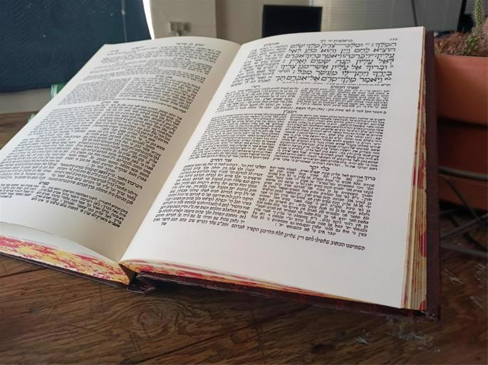

***A standard Chumash (Hebrew Bible) with Rashi's***

***commentary appearing right below the text.***

**8. They Chronicle the First 2488 Years of History**

In addition to the mitzvahs, the Five Books of Moses describe the creation of the universe and the first two-and-half millennia of history. Special emphasis is placed on the stories of our forefathers, Abraham, Isaac, and Jacob, and the events that shaped the Jewish nation: the Egyptian exile, the Exodus, and the giving of the Torah at Mt. Sinai. But don’t be fooled: Far from providing mere historical information, each narrative contains countless lessons as relevant today as when they first occurred.

**9. Scribes Include Moses, Ezra, and**[**Maimonides**](https://www.chabad.org/library/article_cdo/aid/889836/jewish/Maimonides-The-Rambam.htm)

The skill of writing the Pentateuch on parchment is not one mastered easily. Scribes must undergo intense study and training to qualify for the demanding task. Over the ages, scribes of Torah scrolls (as well as *tefillin*and *mezuzahs*) occupied a place of honor within each Jewish community. The first scribe was Moses, who wrote 13 Torah scrolls on the day of his passing.[9](javascript:doFootnote('9a6547955');) Other notable scribes include Ezra, whose Torah scroll was kept in the Temple throughout the Second Temple period;[10](javascript:doFootnote('10a6547955');) Maimonides, who details how he wrote his scroll in his magnum opus, the Mishneh Torah;[11](javascript:doFootnote('11a6547955');) Rabbi Meir of Rothenberg;[12](javascript:doFootnote('12a6547955');) and Rabbi Moshe Isserles.

**10. The Printed Version Is a Synagogue Staple**

In addition to its handwritten format, the Pentateuch is one of the most popular printed books of all time, published in hundreds of editions in multiple languages. You can be sure to find many copies of the Chumash on the shelves of your local synagogue. Although "Chumash" technically refers to each of the individual books (e.g., Chumash [Bereishit](https://www.chabad.org/parshah/default_cdo/aid/7781/jewish/Bereshit.htm), Chumash [Shemot](https://www.chabad.org/library/bible_cdo/aid/8161/jewish/Shemot-Exodus.htm), etc.), it is often used to refer to the collective unit as well.

Far from being limited to synagogues and study halls, a Chumash is a staple of every Jewish home.

**11. There Are Hundreds of Commentaries**

The Torah is the basis of hundreds if not thousands of commentaries, starting from age-old ones such as [Rashi](https://www.chabad.org/library/article_cdo/aid/111831/jewish/Who-Was-Rashi.htm), Nachmanides, and Ibn Ezra, and culminating with new ones being authored as you read this article. Analyzing the text from numerous angles, they share the common goal of uncovering the endless layers of meaning in the sacred text and channeling its messages to the minds and hearts of each generation.

**12. Translations Date Back to Antiquity**

One of the earliest Torah translations is in Aramaic, rendered by Onkelos the Convert in the 2nd century CE, featured alongside the original text in many publications of the Chumash. Other notable early translations include the Greek translation commissioned by King Ptolemy of Egypt in the 3rd century BCE, and (turning the clock ahead a millennium) the Arabic translation of Rabbi Saadia Gaon from the early 10th century.

**13. Oldest Manuscripts Among Dead Sea Scrolls**

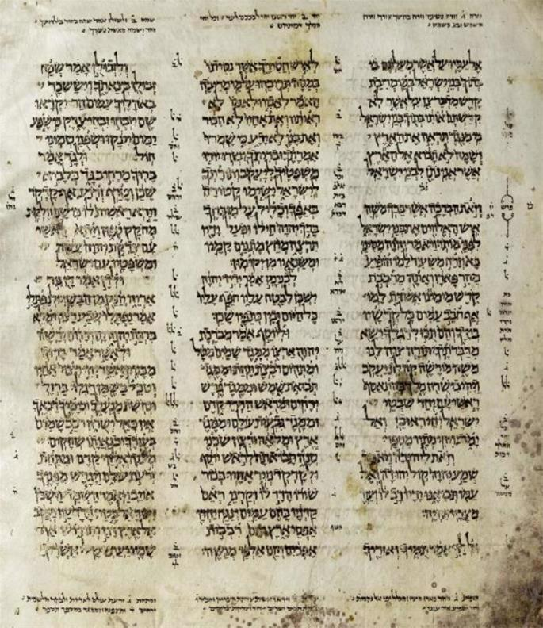

**A page from the Aleppo Codex**

The earliest extant manuscripts of the Five Books of Moses form a significant portion of the famous collection known as the Dead Sea Scrolls. About 100 fragments representing each of the five books were found, including 33 pieces from Deuteronomy alone. This ancient treasure trove is approximately 2,000 years old.

Another famous manuscript copy of the Torah (along with the rest of the [Tanakh](https://www.chabad.org/library/bible_cdo/aid/63255/jewish/Tanakh-The-Hebrew-Bible.htm)) is the Aleppo Codex, written in the 10th century and famous for its accuracy. Used by Maimonides[13](javascript:doFootnote('13a6547955');) and many other influential figures, it is currently kept in the Israel Museum in Jerusalem.

**14. They’re Read Four Times a Week (or More)**

In the Jewish [synagogue service](https://www.chabad.org/library/article_cdo/aid/365940/jewish/The-Synagogue-Prayer-Services.htm), the Torah scroll is removed from the ark and read aloud twice every Shabbat, during the morning and afternoon services. It is also read every Monday and Thursday, as well as on Rosh Chodesh (the beginning of the Jewish month), on fast days, and on all major holidays. The entire text of the Pentateuch is thus completed once a year.

**15. The Reading Is Melodious**

If you’ve heard the Torah reading in a synagogue, you know that far from being monotonous, it is read following a specific tune, known as *ta’amim*in Hebrew or *trop*in Yiddish. The melody is indicated by cantillation marks located beneath or above the words of the text in the printed editions of the Chumash. These marks double as punctuation, indicating where verses end and where to pause within each verse. While the cantillation marks are universal, the melody is not: Ashkenaz, Sephardi, and Yemenite traditions differ in how the words are both pronounced and sung.

**16. They Are Divided Into Weekly Portions**

The Five Books of Moses are divided into 53 weekly segments.[14](javascript:doFootnote('14a6547955');) Each segment is called a *sidra* or *parshah* and is associated with a specific week of the year. It is the weekly [*parshah*](https://www.chabad.org/parshah/default_cdo/aid/6232/jewish/Parshah-Weekly-Torah.htm)that is read from the Torah scroll on Monday, Thursday, and Shabbat. Additionally, many Jews study part of the weekly *parshah* every day, often [with the commentary of Rashi](https://www.chabad.org/dailystudy/torahreading.htm). In addition to the tremendous value of constantly reviewing the most fundamental text of our faith, a Jew “lives” with the weekly Torah portion, looking to it for guidance and inspiration for that week and beyond.

**17. They Are the Basis of All of Jewish Scholarship**

Over the ages, Jewish literature has expanded to fill thousands upon thousands of volumes, including the [Talmud](https://www.chabad.org/library/article_cdo/aid/2537389/jewish/Talmud.htm), Midrash, Zohar, and many more. However, the source of every piece of Jewish scholarship up to today can be traced back to the timeless Divine words of the Five Books of Moses, the seminal and most important work of Judaism of all times.

Top of Form

Bottom of Form

Footnotes

[1.](https://www.chabad.org/library/article_cdo/aid/6547955/jewish/17-Facts-You-Should-Know-About-the-Five-Books-of-Moses.htm" \l "footnoteRef1a6547955) See *Code of Jewish Law, Orach Chaim* 36.

[2.](https://www.chabad.org/library/article_cdo/aid/6547955/jewish/17-Facts-You-Should-Know-About-the-Five-Books-of-Moses.htm" \l "footnoteRef2a6547955) See Talmud, Gittin 60a. Nachmanides in his introduction to his Torah commentary.

[3.](https://www.chabad.org/library/article_cdo/aid/6547955/jewish/17-Facts-You-Should-Know-About-the-Five-Books-of-Moses.htm" \l "footnoteRef3a6547955) See Talmud, Bava Batra 15a and Menachot 30a.

[4.](https://www.chabad.org/library/article_cdo/aid/6547955/jewish/17-Facts-You-Should-Know-About-the-Five-Books-of-Moses.htm" \l "footnoteRef4a6547955) This is true even with the Book of Deuteronomy, which seems to be Moses’s own work—see *Likkutei Sichot*, vol. 19, pp. 9–11.

[5.](https://www.chabad.org/library/article_cdo/aid/6547955/jewish/17-Facts-You-Should-Know-About-the-Five-Books-of-Moses.htm" \l "footnoteRef5a6547955) *Mishneh Torah, Hilchot Teshuvah* 3:8.

[6.](https://www.chabad.org/library/article_cdo/aid/6547955/jewish/17-Facts-You-Should-Know-About-the-Five-Books-of-Moses.htm" \l "footnoteRef6a6547955) Many laws relating to the betrothal of a woman are learned from the juxtaposition of two words in [Deuteronomy 24:2](https://www.chabad.org/9988#v2), for example—see Talmud, Kiddushin 5a, 9b, 44a, et al.

[7.](https://www.chabad.org/library/article_cdo/aid/6547955/jewish/17-Facts-You-Should-Know-About-the-Five-Books-of-Moses.htm" \l "footnoteRef7a6547955) Talmud, Menachot 29b.

[8.](https://www.chabad.org/library/article_cdo/aid/6547955/jewish/17-Facts-You-Should-Know-About-the-Five-Books-of-Moses.htm" \l "footnoteRef8a6547955) See Abarbanel, introduction to Joshua.

[9.](https://www.chabad.org/library/article_cdo/aid/6547955/jewish/17-Facts-You-Should-Know-About-the-Five-Books-of-Moses.htm" \l "footnoteRef9a6547955) [Deuteronomy 31:9](https://www.chabad.org/9995#v9). Devarim Rabbah 9:9.

[10.](https://www.chabad.org/library/article_cdo/aid/6547955/jewish/17-Facts-You-Should-Know-About-the-Five-Books-of-Moses.htm" \l "footnoteRef10a6547955) Jerusalem Talmud, Taanit 4:2, Babylonian Talmud, Moed Katan 18b. See Hayom Yom, 7 Elul.

[11.](https://www.chabad.org/library/article_cdo/aid/6547955/jewish/17-Facts-You-Should-Know-About-the-Five-Books-of-Moses.htm" \l "footnoteRef11a6547955) *Hilchot Sefer Torah* 8:4 and 9:10–11.

[12.](https://www.chabad.org/library/article_cdo/aid/6547955/jewish/17-Facts-You-Should-Know-About-the-Five-Books-of-Moses.htm" \l "footnoteRef12a6547955) See *Hayom Yom*, 7 Elul.

[13.](https://www.chabad.org/library/article_cdo/aid/6547955/jewish/17-Facts-You-Should-Know-About-the-Five-Books-of-Moses.htm" \l "footnoteRef13a6547955) See *Mishneh Torah*,*Hilchot Sefer Torah* 8:4.

[14.](https://www.chabad.org/library/article_cdo/aid/6547955/jewish/17-Facts-You-Should-Know-About-the-Five-Books-of-Moses.htm" \l "footnoteRef14a6547955) See *Shem Hagedolim*, *Maarechet Sefarim*, end of letter *gimmel*.

*Reprinted from the current website of Chabad.Org*

**A Torah Lesson for the Jewish Parents**

“You (plural) shall teach them to your (plural) children to discuss them, while you (singular) sit in your home, while you (singular) walk on the way, when you (singular) retire and when you (singular) arise.” (11:19) Why does the Torah change plural to singular in the middle of the verse?

R’ Yitzchak Menachem Weinberg (Tolner Rebbe in Yerushalayim) explains: The Torah is teaching that successful parenting requires a person to work on himself. “You” alone! Do not rely on the merits of distinguished ancestors. Do not think that your behavior when you are alone, when no one sees you, doesn’t matter.

If a person serves Hashem even when he sits alone at home, when he walks alone on the way, when he retires to bed alone and when he arises alone, then he can teach his children. (Chamin B’Motzai Shabbat: Devarim p.82)

*Reprinted from this week’s email of R’ Yedidye Hirtenfeld’s whY I Matter parsha sheet for the Young Israel of Midwood in Brooklyn.*

**Rav Avigdor Miller on**

**Learning Law in Yeshiva**

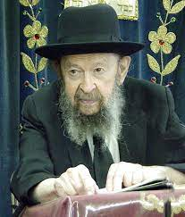

**QUESTION:** Why don’t rabbanim talk more about honesty in business?

**ANSWER:** And the answer is that every day a Jew is getting this lesson.  A little boy goes to the yeshiva and right away he learns *arba avos nezikin*, about all the different forms of damage that he’s responsible for.

Once a man stopped me on the street and he asked me, “Why is my grandson learning law in the yeshiva?  Is he going to be a lawyer? All the halachos of damages he’s learning there.”

I told him what Rav Yisrael Salanter answered.  Rav Yisrael Salanter said that when you grow up and you haven’t learned yet the responsibility you have to a fellow man’s money then it’s already too late.  You’ll never feel any *hargashah* for somebody else’s money.  And therefore, you have to start right from the beginning.

So, the first thing you learn in the yeshiva is that if you damage somebody’s property, you have to pay.

Ohhh! That’s a big *chiddush* for a little child.  He walks into a store, touches this, touches that, he opens up a box of merchandise; he makes harm – he doesn’t know anything about other people’s money.  The first lesson he learns in yeshiva is that he has to pay, that a *mazik* has to pay.

Certainly, Jewish children are being taught that. They’re learning about *gezel* and damages; even a lost object one has to return. The first thing we teach our little children is *mamon acheirim*, other people’s money. That’s the first and most important lesson. So certainly, the Jewish nation is getting that instruction; more than anybody else in the world.

Which nation compares to us?  *Mi k’amcha Yisrael goy echad ba’aretz* – Who can compare to us?  Which nation teaches their little boys not to do harm to other people’s property?  It’s ridiculous! Nobody can compare to the Jewish nation.  *Bava Kama* and *Bava Metzia* and *Bava Basra* are all talking about *mamon acheirim*, about how important other people’s money is.

*Reprinted from a recent email of Toras Avigdor (Tape #E-120 – August 1997).*

**Thoughts that Count**

*If you will say in your heart: These nations are more than I; how can I dispossess them? [Then] you will not be afraid of them* (Deut. 7:17-18)

It is only when a Jew admits that that nations of the world are more physically powerful than he, and that only with G-d's help can he prevail, that he will cease being afraid... (Shaloh)

*And he afflicted you, and suffered you to hunger, and fed you with the manna* (Deut. 8:3)

Even though the manna could assume the taste of any delicacy in the world, the Jews still complained to Moses, "Our soul is dried away, there is nothing at all, we have only the manna to look to." Because they could not actually see the different foods they were eating (the manna always looked the same), it contained an element of "affliction" and "suffering"; moreover, this inability to see prevented them from being fully sated. From this we learn that lighting Shabbat candles, i.e., making sure there is enough illumination at the table, enhances our pleasure of the Shabbat meal. (The Chida)

*And He fed you with the manna...that He might make you know that not by bread alone does man live (Deut. 8:3)*

In the same way that when the Jews in the desert ate the manna ("bread from heaven") they recognized that they were being sustained in a miraculous manner, so too must we be aware that it is not the physical "bread from the earth" that nourishes us, but the G-dly spark it contains.

(Keter Shem Tov)

*Reprinted from the Parashat Eikev 5761/2001 edition of L’Chaim*

**Rabbi Berel Wein on**

**Parshat Ekev 5784**

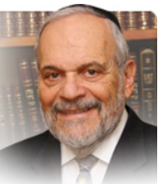

Ekev – the word itself and the parsha generally – stresses the cause-and-effect equation that governs all human and Jewish history. Blessings and sadder events are conditioned on previous human behavior, attitudes and actions. Life eventually teaches us that there is no free lunch. The rabbis stated it succinctly in Avot: “According to the effort and sacrifice, so too will be the reward.”

There are really no shortcuts in life. All attempts to accommodate eternal Jewish practices and values to fit current fads and societal norms, have ended in abysmal failure. The road of Jewish history is littered with the remains of people and movements who looked to reform and improve Judaism and instead only succeeded in making it irrelevant to their followers.

The Torah emphasizes that Moshe brought the people closer to Heaven but he did not degrade heaven by dragging it down to the level of the people. The tragedy of much of American Jewry and of many secular Jews generally is not that Judaism was too hard and difficult – rather, it was rendered too easy and convenient and thus had no meaning in their lives and everyday existence. Moshe in this week’s parsha (as he does generally in the book of Dvarim) emphasizes the difficult times that the people endured in their forty years sojourn and travels in the desert of Sinai. And Moshe does not deign to promise them a rose garden in the Middle East upon their entry into and conquest of the Land of Israel. He warns them of the consequences of abandoning G-d and Torah. The G-d of Jewish and general world history is exacting and does not tolerate the easy path that leads to spiritual weakness and eventual physical destruction.

Rashi in this week’s parsha comments that this message is particularly true regarding the “small” things in life that one easily crushes with one’s akeiv – heel. It is the small thing that truly characterizes our personality and our relationships with others and with our Creator as well.

I have noticed that there is a trend in our current society that when eulogies are delivered, they concentrate on the small things in life – on stories, anecdotes, memories and personal relationships – rather than on the public or commercial achievements of the deceased, no matter how impressive those achievements might have been.

It is the small things in life that engender within us likes and dislikes, feelings of affection and love and emotions of annoyance and frustration. So, our Torah is one of myriad details and many small things. The G-d of the vast universe reveals Himself, so to speak, to us in the atom and the tiny mite. For upon reflection and analysis there are really no small things in life.

Everything that we do and say bears consequences for our personal and national future. It is this sense of almost cosmic influence exercised by every individual in one’s everyday life that lies at the heart of Torah and Judaism. We build the world in our own lives’ seemingly mundane behavior.

Shabat shalom

**The Significant Connection of**

**the “Great Desert” and the Mission of the Jewish People**

**From the Teachings of the Lubavitcher Rebbe**

**Rabbi Menachem Mendel Schneerson, Zt”l**

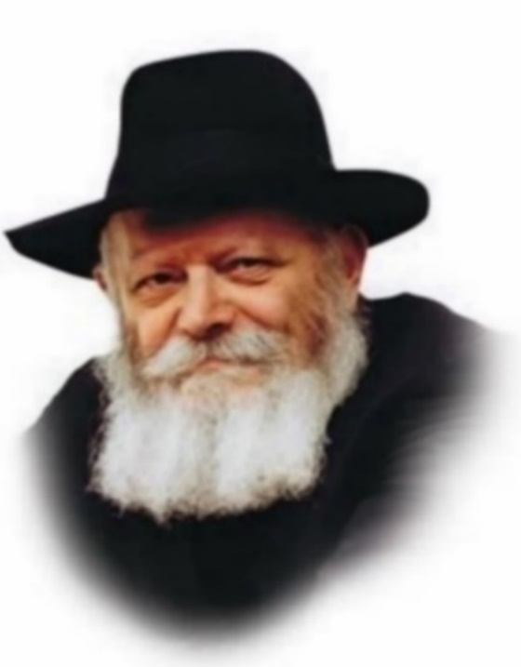

This week's Torah portion, Eikev, talks of the desert in which the Jews wandered before entering the Land of Israel. It is described as: "The great, terrifying desert, where there were snakes, vipers, scorpions and thirst. Where there was no water..."

The great desert symbolizes our long galut (exile). A desert, uninhabited by man, is symbolic of the Jewish people in relation to the other nations of the world. The uninhabited areas of the globe far outnumber the portions which are populated, in the same way that the nations of the world far outnumber the Jews. Furthermore, within the Jewish nation itself, those who observe the Torah and mitzvot are also vastly outnumbered by those who do not yet observe.

The Torah warns us that the very consideration that the outside world is "great" is the first step in causing our spiritual exile. Thinking that because we are outnumbered means that other nations have power over us creates the possibility that these non-Jewish influences can enter our lives.

**The Fear of the Non-Jewish World**

The next spiritual step down is alluded to in the word "terrifying." This is the fear that the non-Jewish world will find out that we keep the Torah. This thinking causes a Jew to measure his behavior according to non-Jewish standards and increases the power of the galut over the Jewish soul.

The next level down is that of "snake." A snake's "hot poison" alludes to the heat and enthusiasm which a Jew can have for things which are really foreign to his essence. When a person's excitement is reserved solely for physical pleasures, his enthusiasm for the spiritual is decreased.

From here, the next jump down is to the level of "vipers"--saraf--which in Hebrew comes from the word "to burn." This is the level on which a person's whole interest toward the satisfaction of his physical desires is so great that it completely overshadows any attraction to G-dliness.

**The Spiritual Danger of Being Cold to Everything**

But even worse than this is the level of "scorpion." A scorpion's sting is cold, symbolizing total coldness and indifference to holiness. Heat and excitement, even if directed toward things which are unworthy, can eventually be redirected into enthusiasm for holiness. But when a person is cold to everything, it is much more difficult to inspire him.

The lowest level belongs to the "thirst, where there was no water." G-d, in His kindness, sometimes causes a Jew to be thirsty for holiness and Judaism, but if one is very far from Torah (called "water" by our Sages), he may not recognize what he is thirsting for. This is the lowest level of our exile.

The antidote to the progression of spiritual degradation is the avoidance of the first pitfall, that of considering the world to have unnecessary significance. By having the proper mind set we will merit the Final Redemption.

*Reprinted from the Parashat Eikev 5761/2001 edition of L’Chaim, a publication of the Lubavitch Youth Organization in Brooklyn. Adapted from the works of the Lubavitcher Rebbe.*